New Year, New Class Notebook

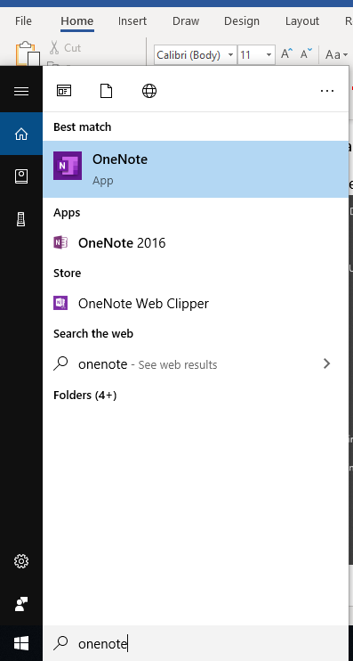Notes: To complete these tasks work inside the OneNote app (One Note on desktop, no year)  
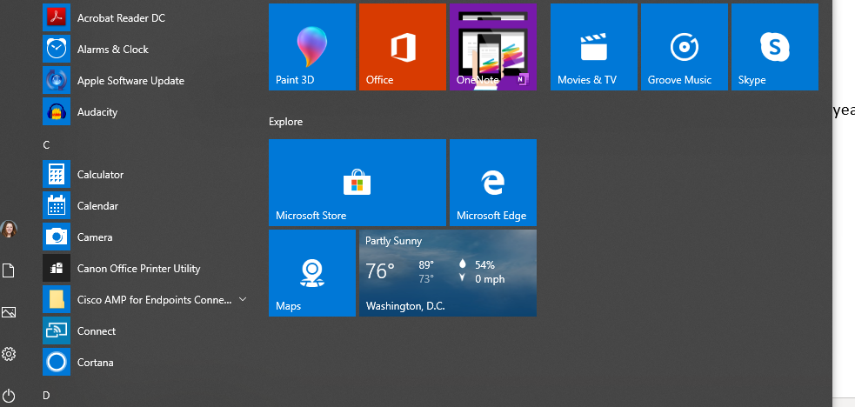

The workflow is this:

1. Create a new OneNote Class Notebook
2. Add Students and Co-teachers
3. Go to previous OneNote Class Notebook  
   and copy in all of the content you want  
   from this year.
4. Inside the app, click on the create notebook icon.



1. That will take you online and prompt you to set up your students and co-teachers.
   1. 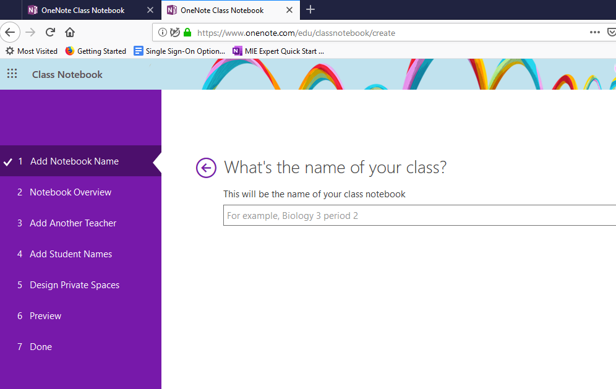Tips: If you made a group in Outlook, you can type the group name. You can paste in email addresses from PowerSchool’s email tool
2. When done, click on “Open in OneNote” , if prompted, pick the app not the one with the year.  
   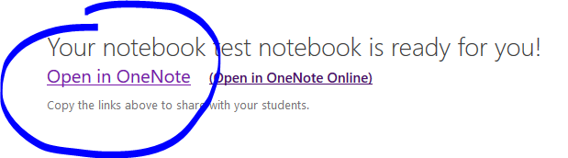
3. Copy the Content Library or any other folders or sections that need to be moved to the new class. Go back to the original class. Right click on the folder you want to copy to the new class, select “Move/Copy”  
   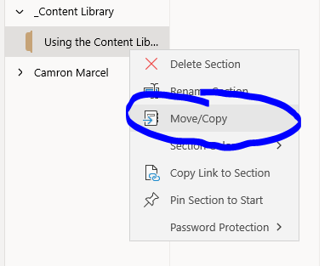
   1. Click on the new class and select the area where you want the new information to go, and select “Copy”
   2. Repeat this as many times as needed to get all of your old information copied into the new class.